**MICROSOFT AZURE**

**Name :** SANJANA V

**Department :** Btech. Artificial Intelligence and Data Science

**GitHub :** https://github.com/sanjana1925/wepage1.git

1. **REQUESTING A CLOUD SHELL SUCCEEDED.**

**SandBox:**

**Welcome to Azure Cloud Shell**

* az vm create --resource-group "learn-1dd151f8-37c6-44cc-a975-8f08e65c30c2" --name my-vm --public-ip-sku Standard --image Ubuntu2204 --admin-username azureuser --generate-ssh-keys
* az vm extension set --resource-group "learn-1dd151f8-37c6-44cc-a975-8f08e65c30c2" --vm-name my-vm --name customScript --publisher Microsoft.Azure.Extensions --version 2.1 --settings '{"fileUris":["https://raw.githubusercontent.com/MicrosoftDocs/mslearn-welcome-to-azure/master/configure-nginx.sh"]}' --protected-settings '{"commandToExecute": "./configure-nginx.sh"}'
* sudo apt-get update
* ssh azureuser@ 13.87.188.36
* echo "sudo apt-get update -y
* sudo apt-get install nginx -y
* sudo systemctl start nginx
* sudo systemctl enable nginx" > setup_nginx.sh
* chmod +x setup_nginx.sh
* ./setup_nginx.sh
* echo "<html><body><h2>Welcome to Azure! My name is $(hostname).</h2></body></html>" | sudo tee -a /var/www/html/index.html
* sudo systemctl status nginx
* az vm open-port --resource-group "learn-1dd151f8-37c6-44cc-a975-8f08e65c30c2" --name my-vm --port 80
* az vm list-ip-addresses --resource-group "learn-1dd151f8-37c6-44cc-a975-8f08e65c30c2" --name my-vm --output table
* ssh azureuser@ 13.87.188.36
* sudo apt-get update
* git clone <https://github.com/sanjana1925/wepage1.git>
* sudo cp -r html/* /var/www/html/
* sudo chown -R www-data:www-data /var/www/html
* sudo chmod -R 755 /var/www/html
* sudo systemctl restart nginx

**WORKING:**

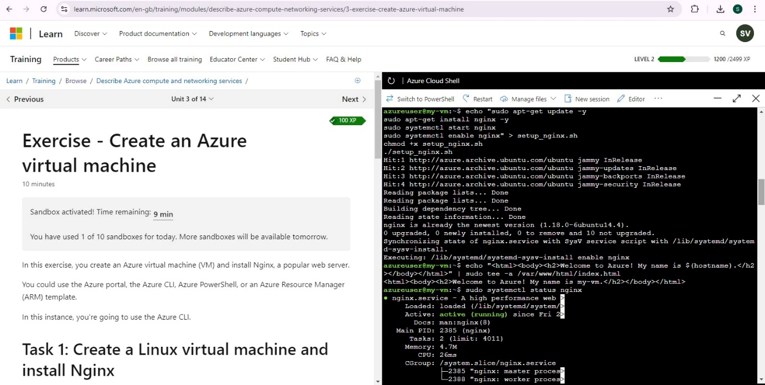

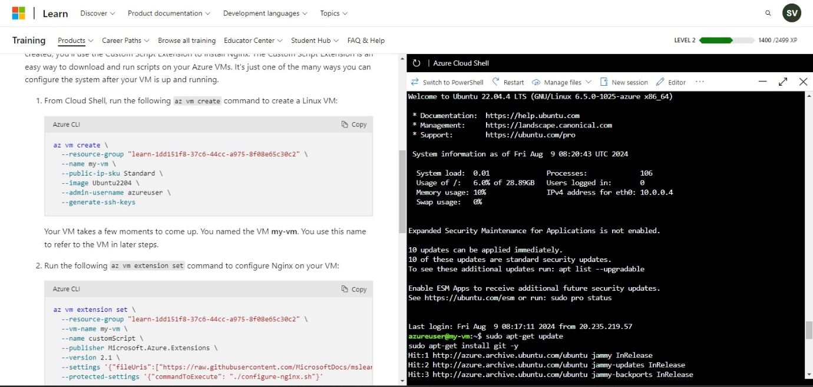

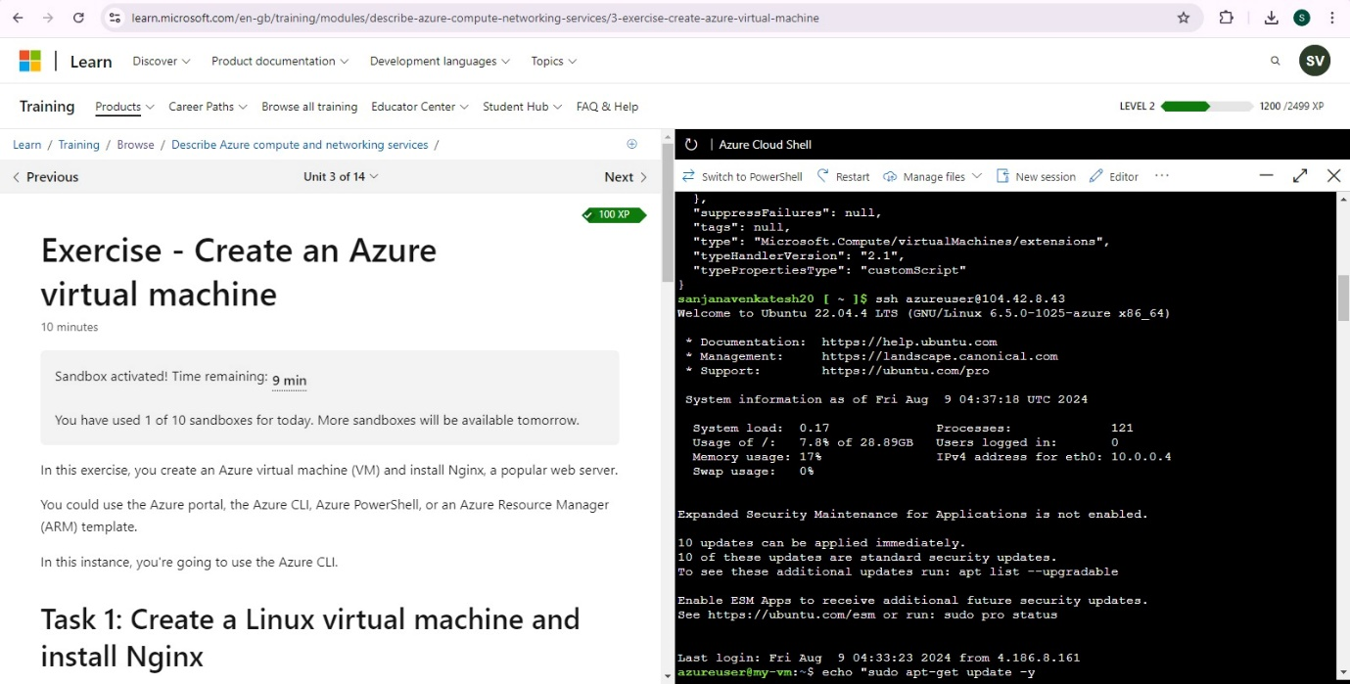

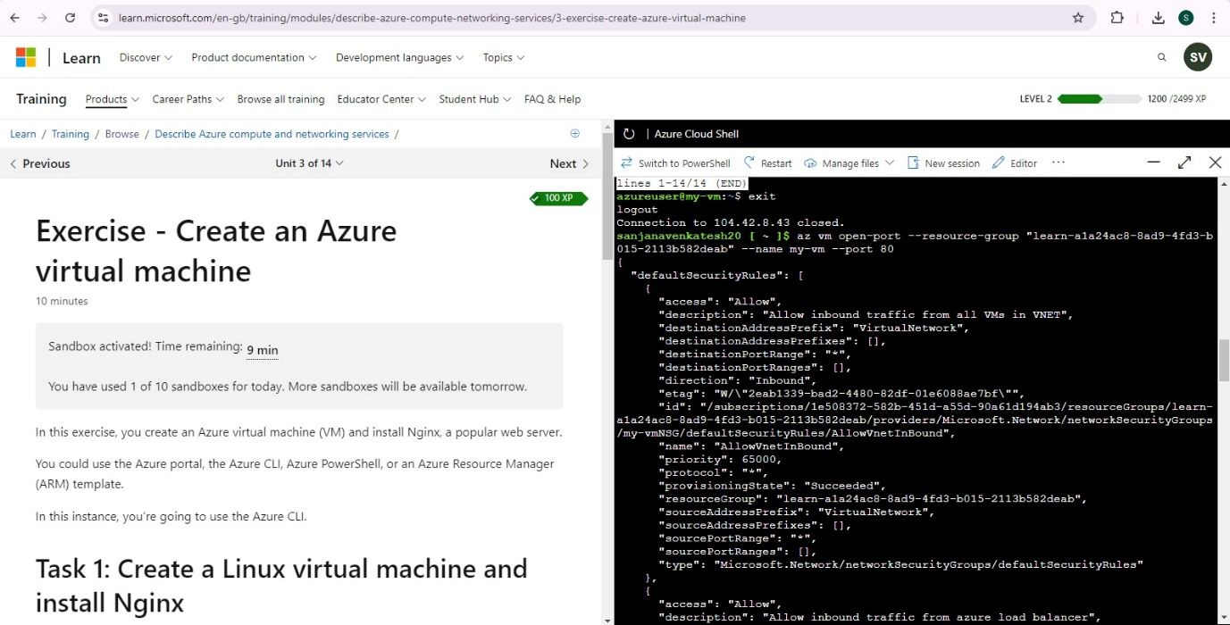

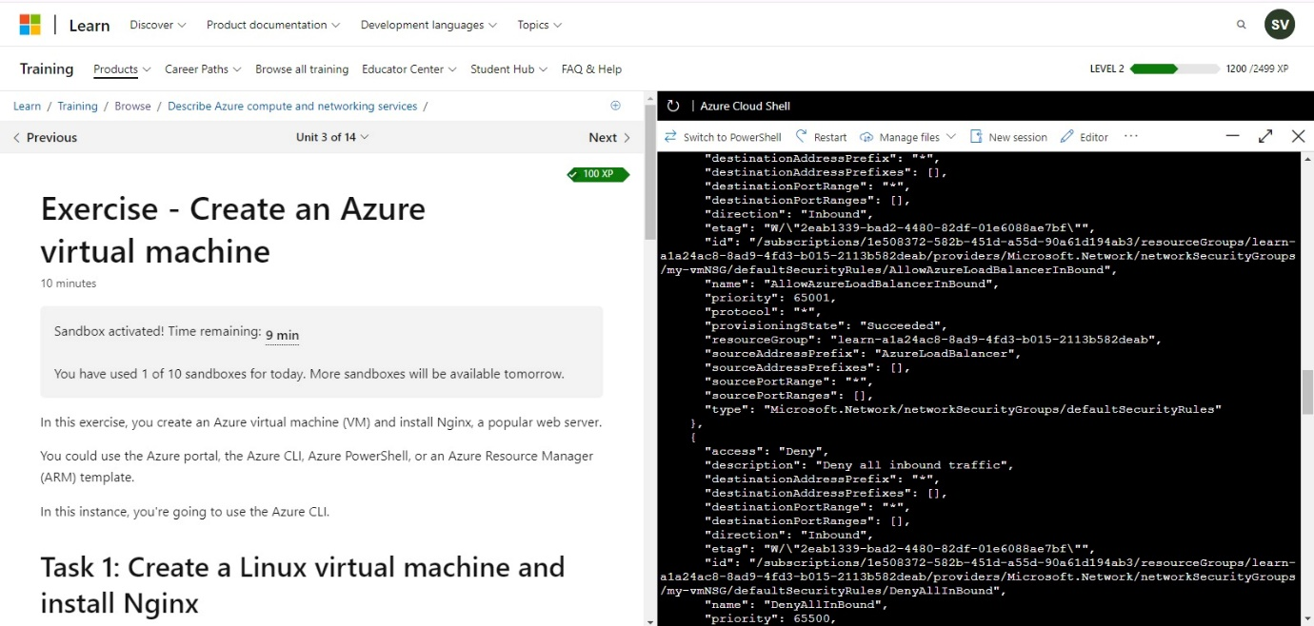

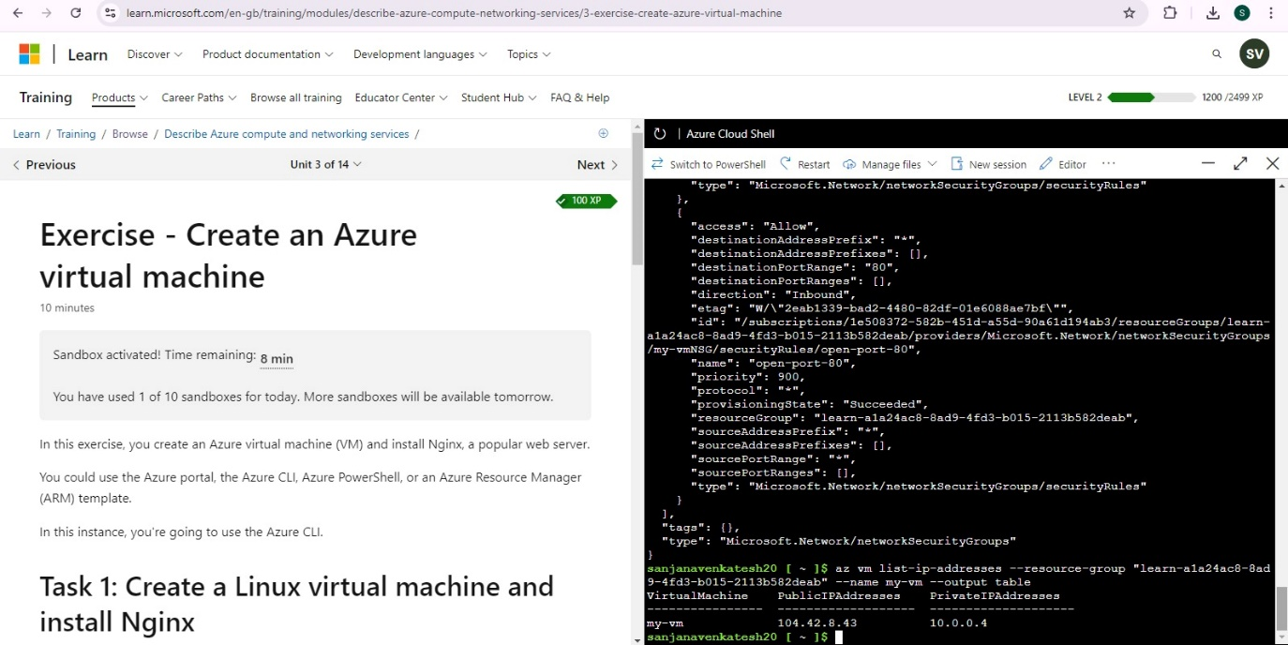

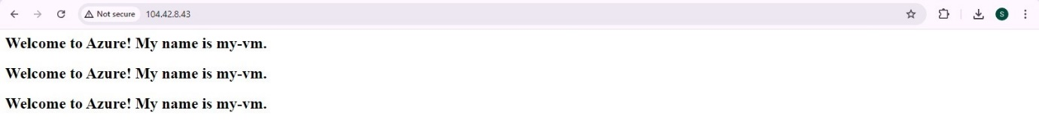

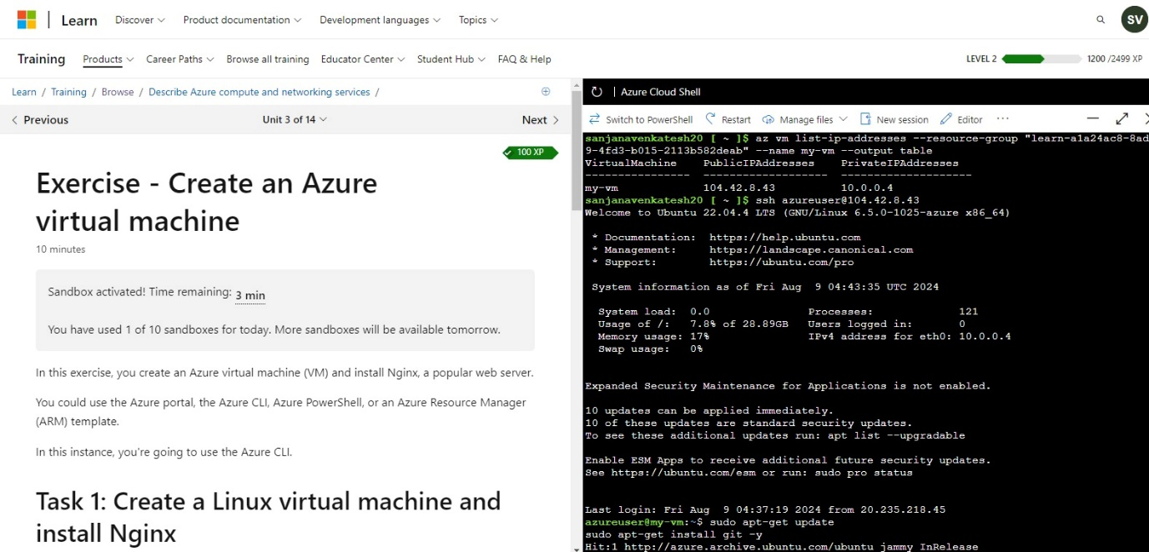

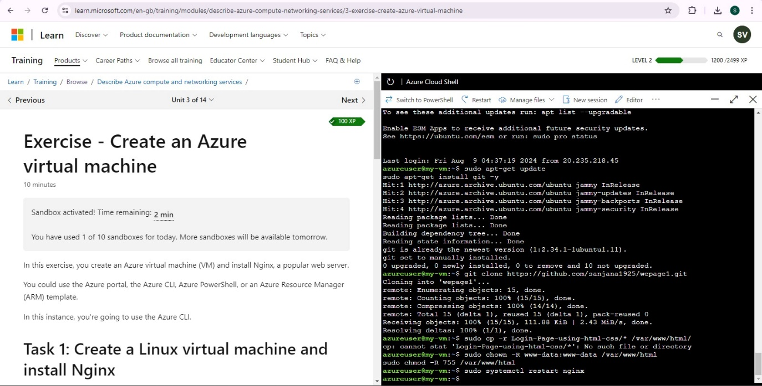

**OUTPUT:**

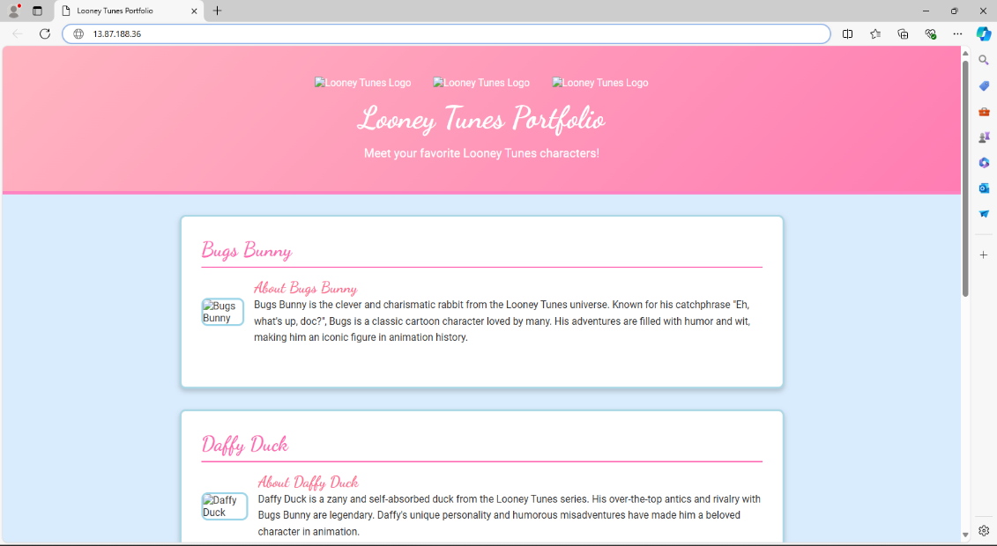

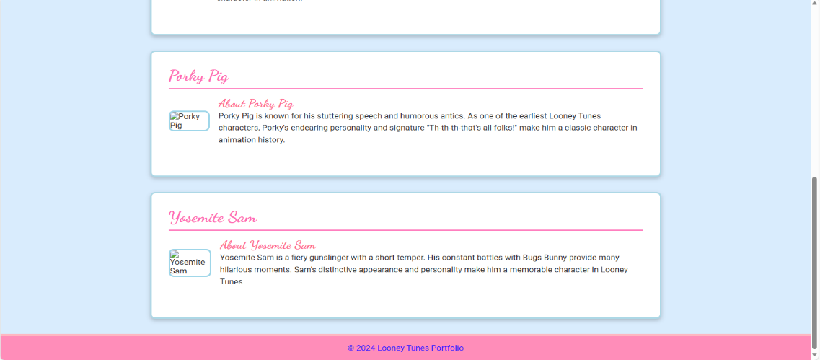

**2. DESCRIBE AZURE STORAGE SERVICES**

**WORK WITH BLOB STORAGE**

In this section, you'll create a Blob container and upload a picture.

1. Under **Data storage**, select **Containers**.
2. Select **+ Container** and complete the information.
3. Select Create.

**Note**

Step 4 will need an image. If you want to upload an image you already have on your computer, continue to Step 4. Otherwise, open a new browser window and search Bing for an image of a flower. Save the image to your computer.

1. Back in the Azure portal, select the container you created, then select Upload.
2. Browse for the image file you want to upload. Select it and then select upload.

**Note**

You can upload as many blobs as you like in this way. New blobs will be listed within the container.

1. Select the Blob (file) you just uploaded. You should be on the properties tab.
2. Copy the URL from the URL field and paste it into a new tab.

* **Change the access level of your blob**

1. Go back to the Azure portal.
2. Select Change access level.
3. Set the Anonymous access level to Blob (anonymous read access for blobs only).
4. Select OK.
5. Refresh the tab where you attempted to access the file earlier.

**WORKING:**

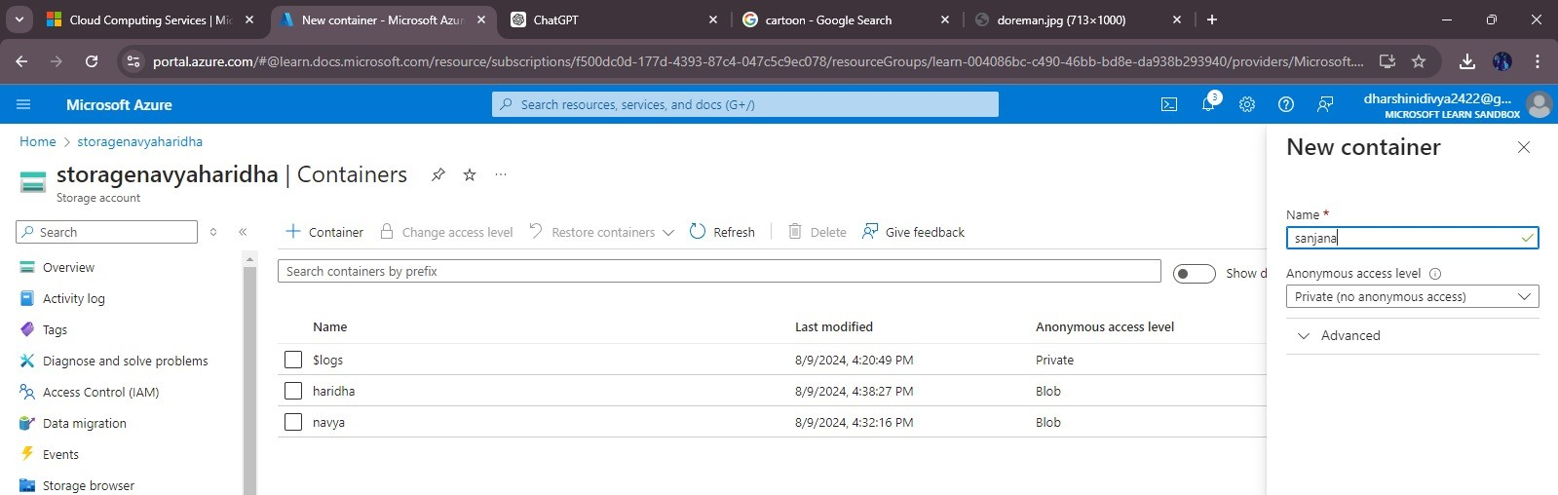

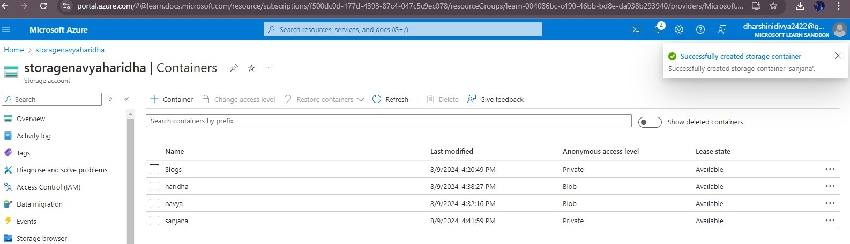

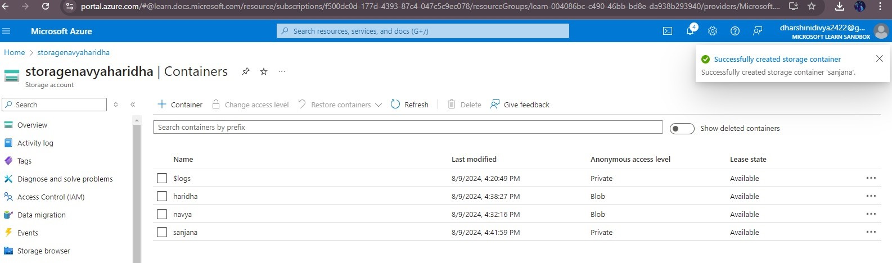

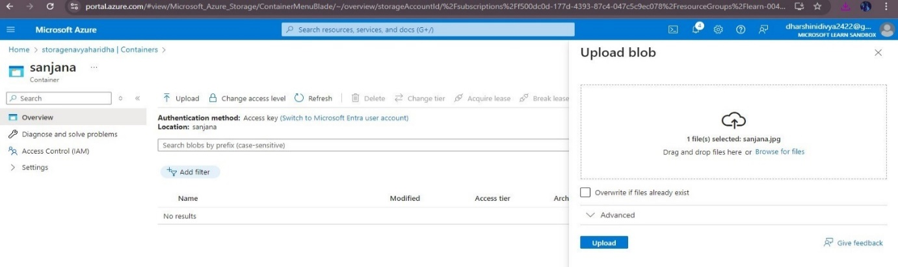

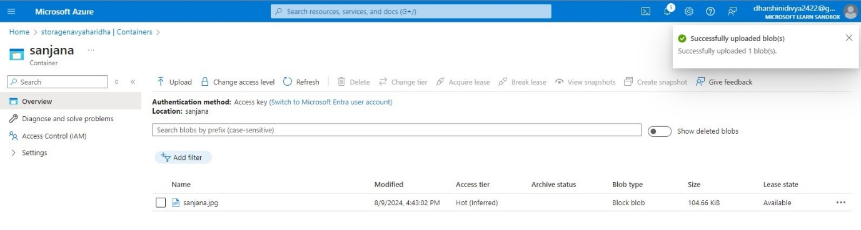

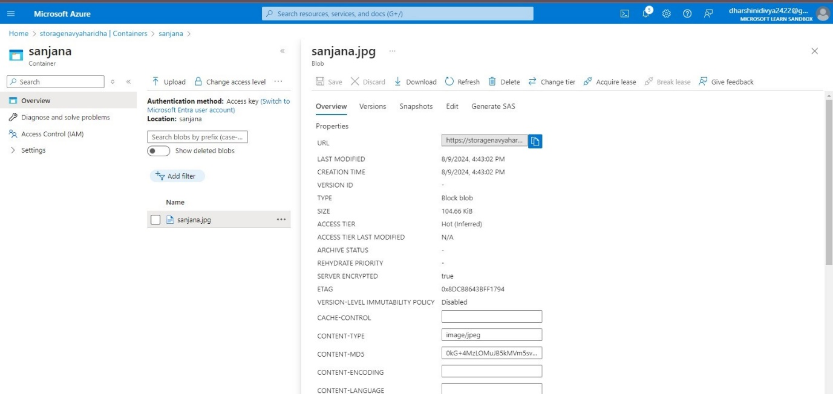

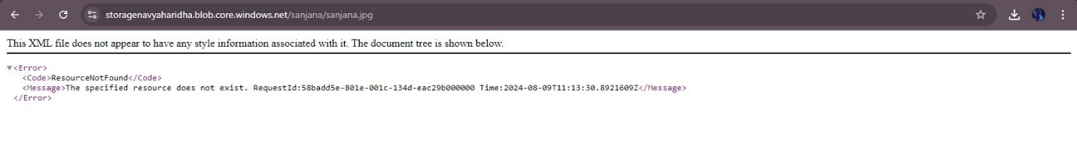

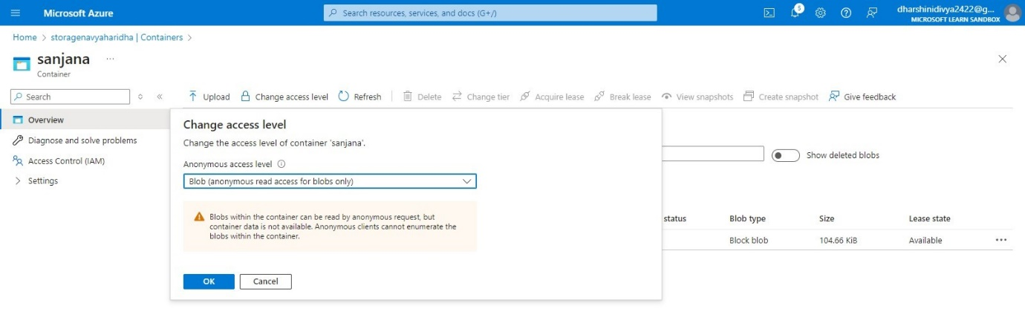

**OUTPUT :**



**3. ESTIMATE WORKLOAD COSTS BY USING THE PRICING CALCULATOR**

* Explore the Pricing calculator

1. Go to the [Pricing calculator](https://azure.microsoft.com/pricing/calculator/).
2. Notice the following tabs:
   * Products This is where you choose the Azure services that you want to include in your estimate. You'll likely spend most of your time here.
   * Example scenarios Here you'll find several *reference architectures*, or common cloud-based solutions that you can use as a starting point.
   * Saved estimates Here you'll find your previously saved estimates.
3. Estimate your solution

* Here you add each Azure service that you need to the calculator. Then you configure each service to fit your needs.
* Tip
* Make sure you have a clean calculator with nothing listed in the estimate. You can reset the estimate by selecting the trash can icon next to each item.
* Add services to the estimate

1. On the Products tab, select the service from each of these categories:
2. Scroll to the bottom of the page. Each service is listed with its default configuration.

* Configure services to match your requirements:

1. Under Virtual Machines, set values.
2. Under Azure SQL Database, set values.
3. Under Application Gateway, set values.

* Review, share, and save your estimate
* At the bottom of the page, you see the total estimated cost of running the solution. You can change the currency type if you want.
* At this point, you have a few options:
* Select Export to save your estimate as an Excel document.
* Select Save or Save as to save your estimate to the Saved Estimates tab for later.
* Select Share to generate a URL so you can share the estimate with your team.

**WORKING :**

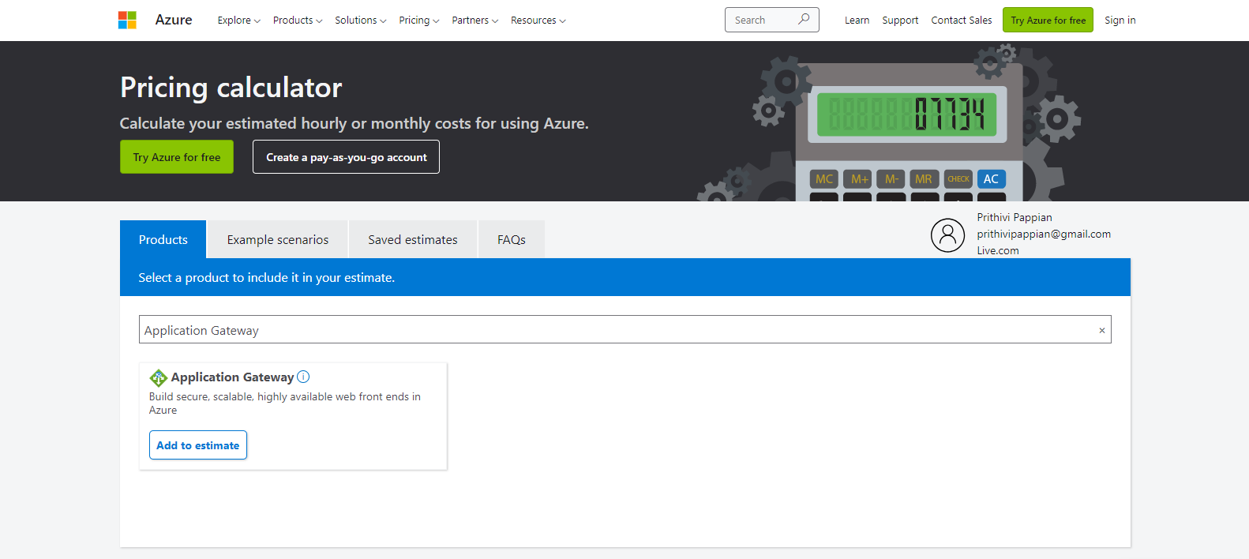

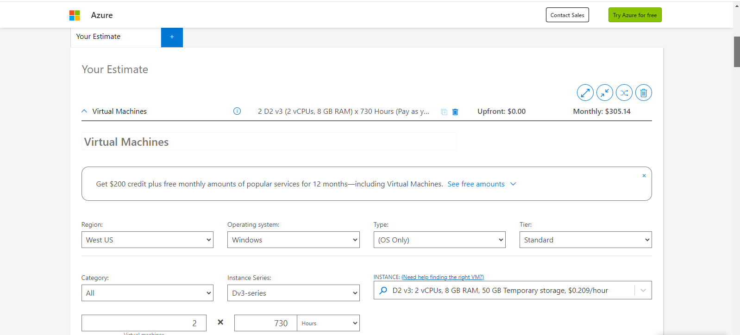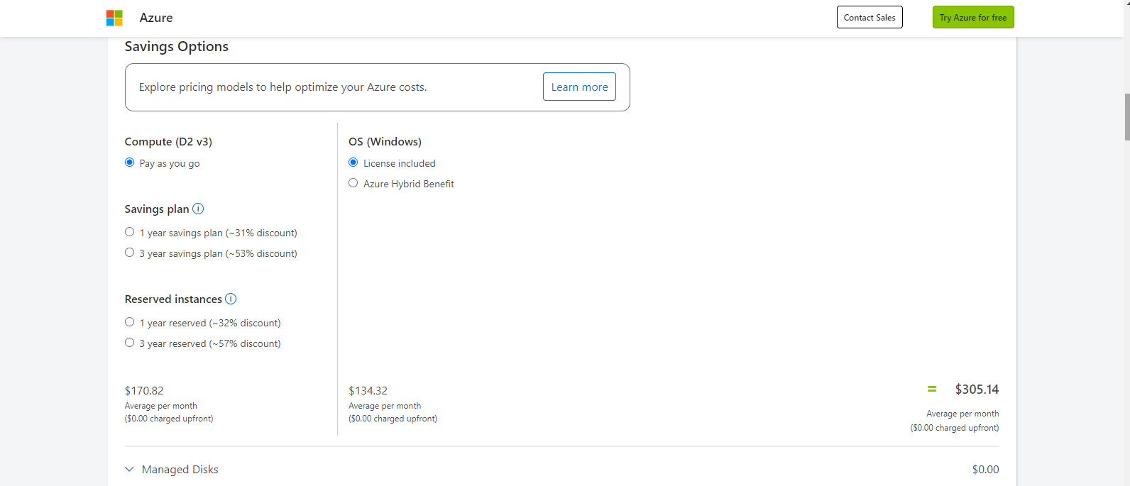

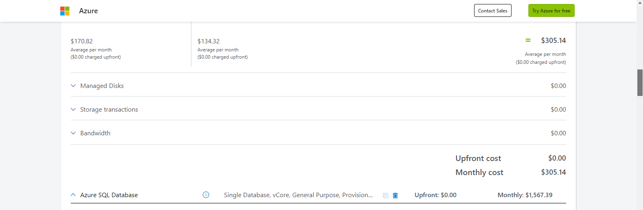

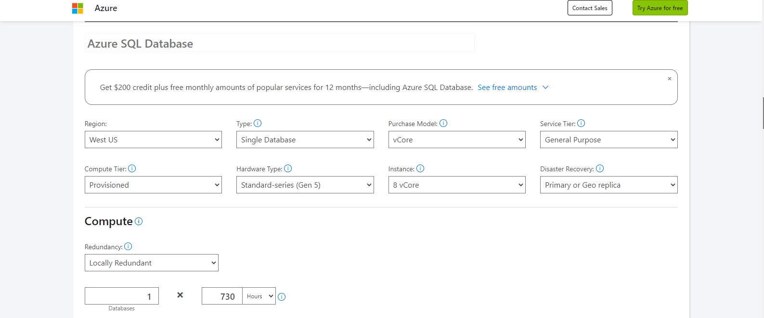

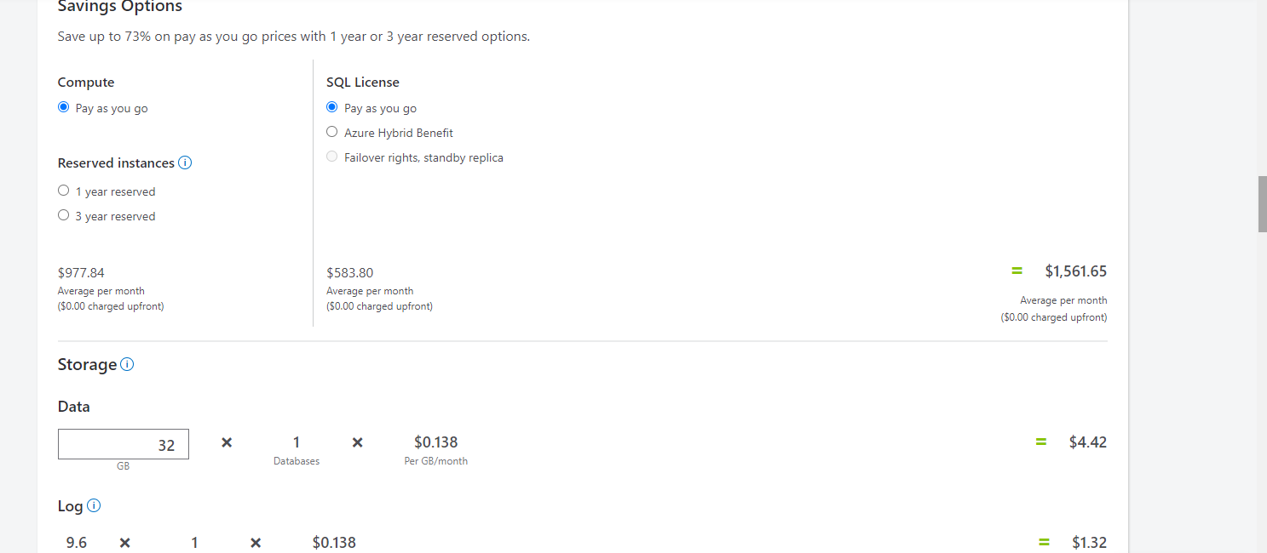

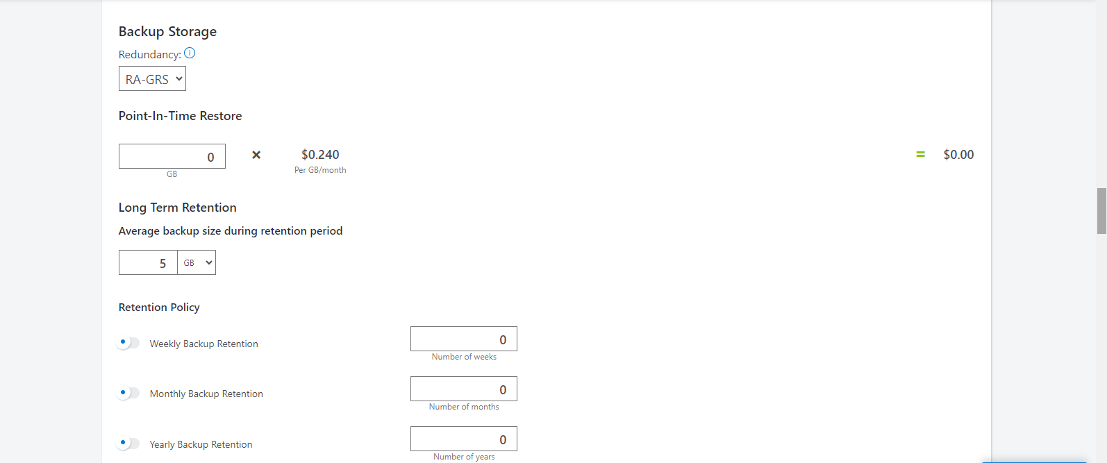

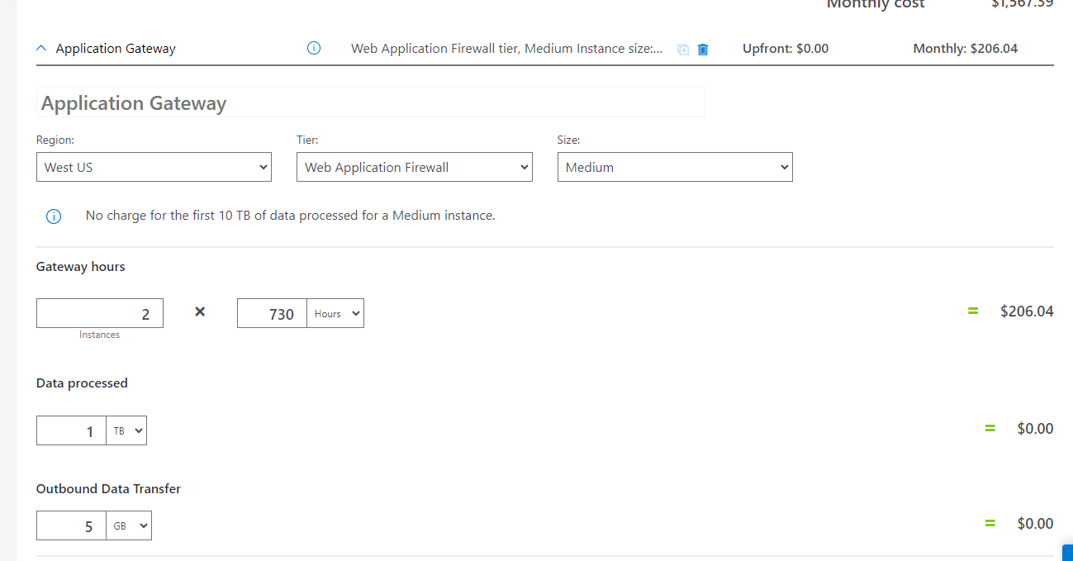

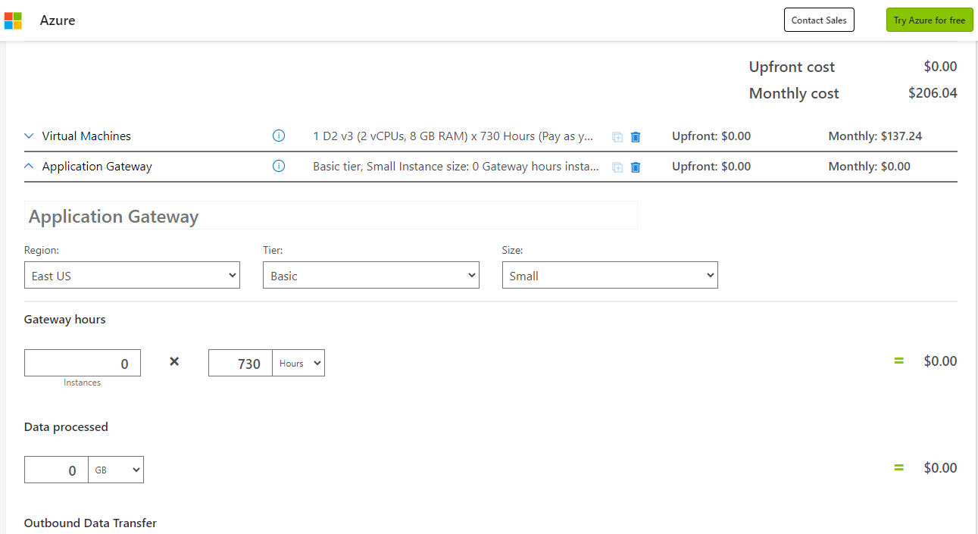

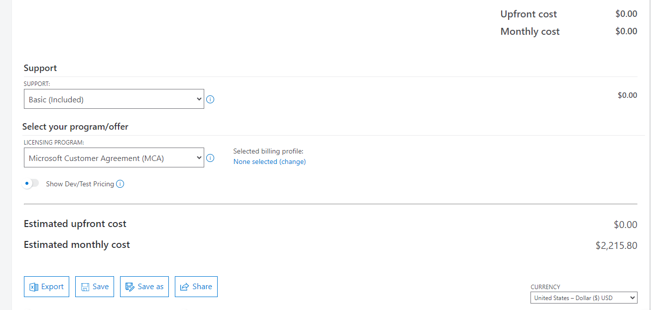

**OUTPUT :**

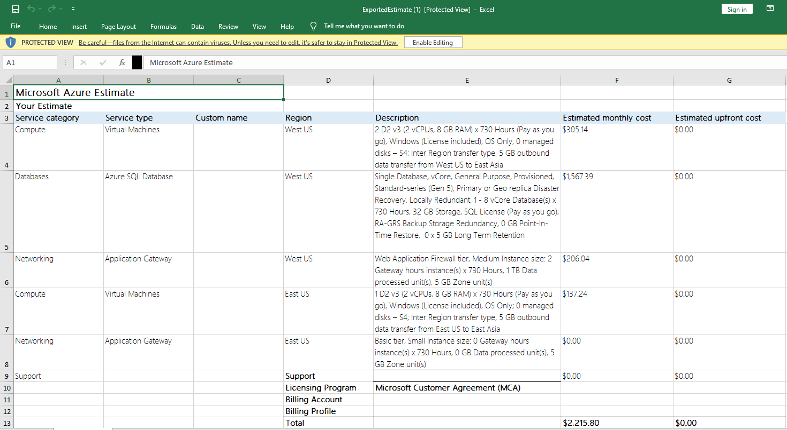

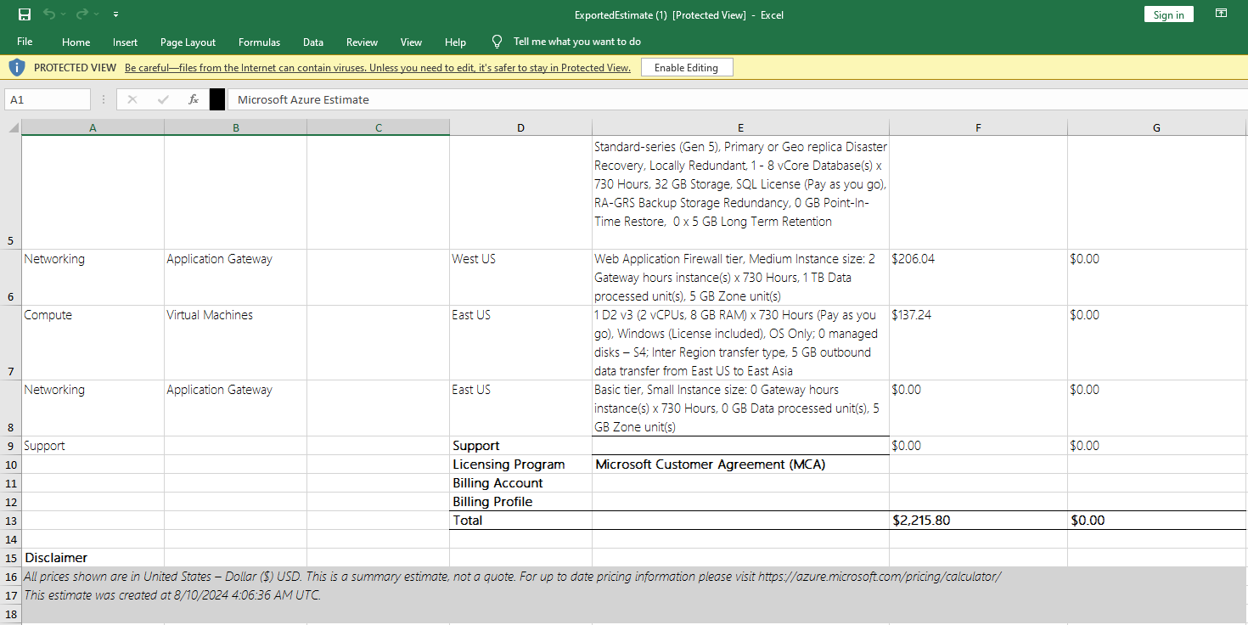

**Link** : https://azure.com/e/a5907a2ed6f84d81bb542e445de00b00

**4. COMPARE WORKLOAD COSTS USING THE TCO CALCULATOR**

* Define your workloads

Enter the specifications of your on-premises infrastructure into the TCO Calculator.

1. Go to the [TCO Calculator](https://azure.microsoft.com/pricing/tco/calculator).
2. Under **Define your workloads**, select **Add server workload** to create a row for your bank of Windows Server VMs.
3. Under **Servers**, set the value for each of these settings.
4. Select **Add server workload** to create a second row for your bank of Linux VMs. Then specify these settings.
5. Under **Storage**, select **Add storage**. Then specify these settings.
6. Under **Networking**, set **Outbound bandwidth** to **15 TB**.
7. Select **Next**.

* In practice, you would adjust any cost assumptions and make any adjustments to match your current on-premises environment.
* At the top of the page, select your currency. This example uses **US Dollar ($)**.
* Select **Next**.
* **View the report**
* Take a moment to review the generated report.
* Remember, you've been tasked to investigate cost savings for your European datacenter over the next three years.

To make these adjustments:

1. Set **Timeframe** to **3 Years**.
2. Set **Region** to **North Europe**.

Scroll to the summary at the bottom. You see a comparison of running your workloads in the datacenter versus on Azure.

**WORKING :**

